**BIOLOGICAL LABORATORY (BIO F110) MANUAL**



**DEPARTMENT OF BIOLOGICAL SCIENCES**

**BIRLA INSTITUTE OF TECHNOLOGY AND SCIENCE – PILANI**

**K.K. BIRLA GOA CAMPUS, GOA**

**CONTENTS**

* **Preface**
* **Laboratory instructions**
* **Personal record**
* **Experiments:**

**Experiment 1:** Measurement of total protein content in the given sample.

**Experiment 2:** Measurement of glucose concentration in the given sample.

**Experiment 3:** Measurement of mitotic index and duration of mitosis in the given plant tissue.

**Experiment 4: a.** Measurement of Haemoglobin content in human blood.

**b.** Determination of ABO-Rh Blood Typing.

**Experiment 5:** Quantitation of DNA.

**Experiment 6:** Determination of the Km of phosphatase enzyme.

**Experiment 7:** Separation of chlorophyll pigments by paper chromatography.

**Experiment 8:** Study the phenomenon of plasmolysis in onion peel.

**Experiment 9: a.** Determination of the level of total cholesterol present in serum.

**b.** Determination of Body Mass Index.

**Experiment 10:** Measurement of Blood Pressure.

**Experiment 11:** Observation of permanent slides and comments.

**Experiment 12:** Computational annotation of nucleic acids and proteins.

**Experiment 13:** Tissue location of the endogenous enzyme polyphenol oxidase in the given samples.

* **Bibliography**

**Preface**

*“The aim of science is to extend our thinking and reduce it to order.”*

**-Niels Bohr**

The spectacular progress over the past two decades in our understanding of biological processes at the molecular level has been made possible by the coming together of physical, chemical, biochemical and genetic approaches and by the availability of a wide range of analytical techniques. This course involves experiments designed to strengthen many theoretical concepts learnt in the General Biology course.

This manual provides an introduction to a variety of analytical techniques to the students across the institute with the objective to give them their first laboratory exposure in biology.

Some salient features of this manual are:

* Each experiment includes theoretical, practical and pedagogical material
* Designed for maximum versatility and ease of use for the student
* Review questions test the degree of knowledge obtained through the exercise

The authors gratefully acknowledge the continuous interest and encouragement received from the Director, Head of Department - Biological sciences and faculty of the department of biological sciences. We also extend our gratitude to our Teaching assistants and Technical assistants, Mrs. Kamna Upadhyay, Mr. Paraj Kamat Malyekar and Mr. Mahadev Shetkar for all the support and encouragement.

**General Laboratory Instructions**

* The objective of these laboratory exercises is to acquaint you with the techniques emphasizing the need of measurements in the field of biology. We want you to take serious interest in conducting these experiments, which will help you to have enough exposure in answering the basic questions in modern biology.
* Each student is expected to be on time in the laboratory and come well prepared for the experiment.
* Every student has to have his/her individual printed version of the manual for recording the experimental observations. The laboratory manual and tentative schedule will be available at Moodle.
* The laboratory work will continue for two hours, wherein the students are expected to be fully engaged for the specified time and cannot leave the laboratory before time.
* Students are expected to cooperate with your team members.
* Results of all the experiments should be verified by your section instructors.
* Bring your graph sheets, calculator, scale, pencil etc. and complete the calculations in the laboratory itself.
* Handle the apparatus with care while working. Report any sort of breakage to the instructor.
* Any misbehavior with the instructors shall be punishable.
* If any student misses a given experiment, due to a valid reason, then the student can apply for makeup, However, **makeup for any experiments shall be provided only in extreme cases.**
* Prior to makeup, student must report the reason for absence to their respective section instructors.

**Record for Biology Laboratory**

Name: _________________________ ID No.:__________________ Section no.____

| Sr. No. | Experiment | Date | Instructor’s signature |
| --- | --- | --- | --- |
| 1. |  |  |  |
| 2. |  |  |  |
| 3. |  |  |  |
| 4. |  |  |  |
| 5. |  |  |  |
| 6. |  |  |  |
| 7. |  |  |  |
| 8. |  |  |  |
| 9. |  |  |  |
| 10. |  |  |  |
| 11. |  |  |  |
| 12. |  |  |  |
| 13. |  |  |  |

**EXPERIMENT 1**

**Objective:**

Measurement of total protein in a given sample by Lowry’s method.

**Theory:**

The proteins present in blood plasma are subjected to Biuret reaction with alkaline copper solution, the peptide form chelates with copper ions. This chelate compound in presence of Folin’s reagent gives a characteristic blue colour. This colour so formed is due to the reaction of the alkaline copper with the protein and the reduction of phosphomolybdate (present in Folin’s reagent) by tyrosine and tryptophan present in the protein. The intensity of the blue colour of the solution is directly proportional to the amount of these aromatic amino acids present in the sample. This intensity of colour is measured as optical density by spectrophotometer at 740nm (red filter) because at this wavelength blue complex absorb maximum light.

Spectrophotometer:

The spectrophotometer is an important analytical instrument that makes possible a quantitative measurement of the light passing through a clear solution. The first step in such an analysis is to determine the optimum wavelength (i.e colour of light) to use the analysis. A Spectrophotmeter is an instrument that measures the intensity of the light entering a sample and the light exciting a sample and compares the two intensities.

I/Io = Transmittance.

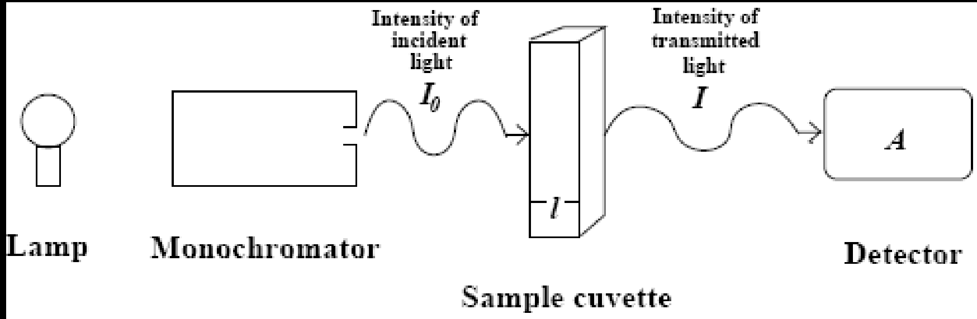

The wavelength that is chosen must be appreciably absorbed by the substance under analysis; else a measurement of transmitted light would not be a significant measure of the concentration of the desired substance. On the other hand, the substance must not absorb too much of the wavelength chosen, else the transmitted light might be of too weak intensity to measure accurately. It can be shown mathematically that the best compromise between too much and too little absorption comes in the region around 36.8% T. (That is the region where the error in reading the absorbance is least, in comparison with the actual absorbance of the substance.)

In order to determine the concentration of a solution quantitatively by measuring the amount of light it transmits, one obviously needs some workable relationship between the solution’s concentration and its transmission of light. The Beer – Lambert Law, sometimes known more simply as “Beer’s Law”, provides such a relationship.

Beer – Lambert’s Law:

Beer Lambert’s law is a combination of Beer’s law and Lambert’s law.

Beer’s law: When a ray of monochromatic light passes through an absorbing medium, its intensity decreases exponentially as the concentration of absorbing medium increases.

I = Io e-kc ------------------------ (1)

Lambert’s Law: When a ray of monochromatic light passes through an absorbing medium then its intensity decreases exponentially as the length of the absorbing medium increases.

I = Io e-kl ------------------------ (2)

Where l = path length

Combining eqn (1) and (2), we have

logIo/I = kcl where k = molar extinction coefficient for absorbing medium

c = concentration

l = path length

log Io/I is the absorbance

So, Absorbance = kcl

and I/Io = transmittance.

Conceptually, the transmittance is an easier quantity to understand; If T = 30%, then 30% of the photons passing through the sample reach the detector, and the other 70% are absorbed by the analyte. If A = 0; then no photons are absorbed.

**Requirements:**

Reagent A: Dissolve 20gm Na2Co3 and 4gm NaOH in 1 litre of distilled water.

Reagent B: Dissolve 0.5 g CuSO4.5H2O and 1.0gm Sodium Potassium Tartarate in 100ml of distilled water.

Reagent C: To 50ml, Reagent A, add 1ml reagent B (prepare fresh)

Reagent D: Diluted (1N) Folin’s & Ciocalteu.

Examining samples:

1. Protein standard solution:
2. Stock solution: Dissolve 0.5g of bovine serum albumin in 50ml of distilled water and store in the refrigerator.
3. Working standard: Dilute the stock solution 10 times so that final protein concentration is 1 mg/ml.

**Procedure:**

1. Take 6 clean test tubes and mark them as B (blank), S1, S2, S3, S4 (different concentrations of standard) and T ( Test solutions). Fill in these test tubes in the following way:

|  | B | S1 | S2 | S3 | S4 | T |
| --- | --- | --- | --- | --- | --- | --- |
| Standard solution | -- | 0.25ml | 0.50ml | 0.75ml | 1.0ml | -- |
| Water | 1ml | 0.75ml | 0.50ml | 0.25ml | -- | -- |
| Test solution | -- | -- | -- | -- | -- | 1.0ml |
| Final conc. (mg/ml) | 0.00 | 0.25 | 0.5 | 0.75 | 1 | ? |

1. Add 5.0ml of alkaline copper solution (reagent –c) in each tube and keep. Allow them to stand for 10min at room temperature.
2. Add 0.5ml of reagent D (diluted Folin) in each tube. Mix immediately and incubate at room temperature for 20min, until blue colour develops.
3. Read OD at 740nm using a blank solution to set zero.

**Observations:**

1. Record OD in the following table:

| **Tube number** | **Concentration of protein** | **OD at 740nm** |
| --- | --- | --- |
| B |  |  |
| S1 |  |  |
| S2 |  |  |
| S3 |  |  |
| S4 |  |  |
| T |  |  |

1. Plot the values of OD 740nm against different concentrations of standard protein solution in the graph paper for preparation of standard curve.
2. Match the OD of T (test sample) on the standard curve. The corresponding concentration on the X axis will be the actual protein concentration (in g/ml) in the given test sample.

**Result:**

The protein concentration in the given sample is ________________mg/ml.

**Marks obtained:**

**Signature of Instructor:**

**Review Questions:**

1. Name two invasive and one non-invasive method of protein estimation.
2. Name two aromatic amino acids which help in protein estimation by Lowry’s method/
3. What protein have you used in Lowry’s method to obtain your standard curve?
4. What is the function of serum albumin in blood?
5. Why do too densely colored samples fail to give proper results using spectrophotometer?

**EXPERIMENT 2**

**Objective:**

To determine the concentration of glucose present   in the given sample of blood,

using the Folin-Wu method.

**Theory:**

Glucose is an aldohexose, belonging to the carbohydrate family and is found in large quantities throughout the living world. It is the primary fuel for living cells. Dietary sources include plant starch. lactose, maltose and sucrose. In nature, glucose exists as D-glucose (Dextrose).

Glucose is a simple sugar (monosaccharide). In solution, it exists as an open chain form (less than 1%), and cyclised ring forms – α – D-glucose (36%). And β– D- glucose (63%).

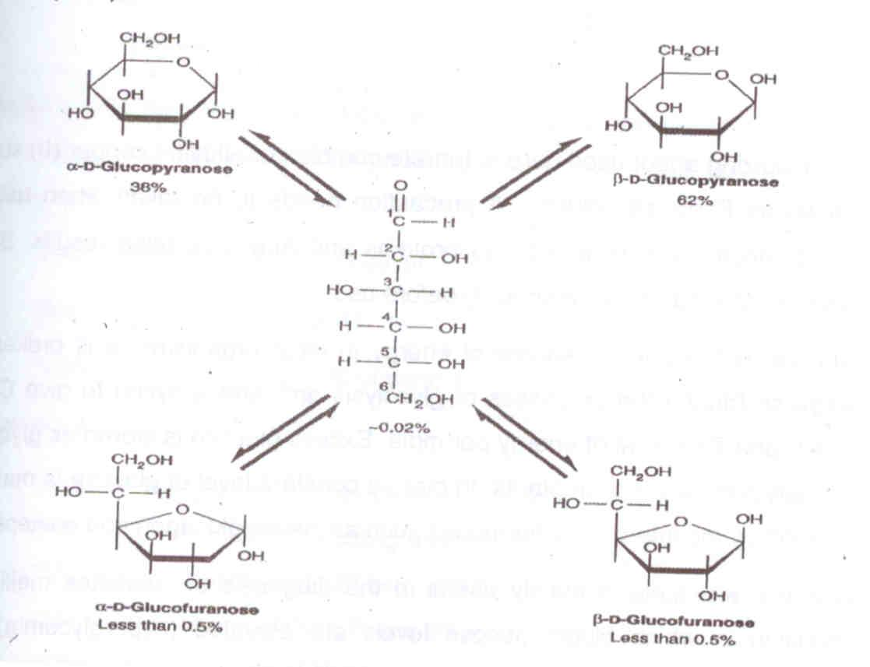

Glucose is a reducing sugar. It is able to function as a reducing agent, because free or potentially free, aldehyde group is present in the molecule. This aldehyde group is readily oxidized to gluconic acid at neutral pH by mild oxidizing agents and enzymes. This property is utilized in detecting and quantitating glucose in biological fluids such as blood or urine.

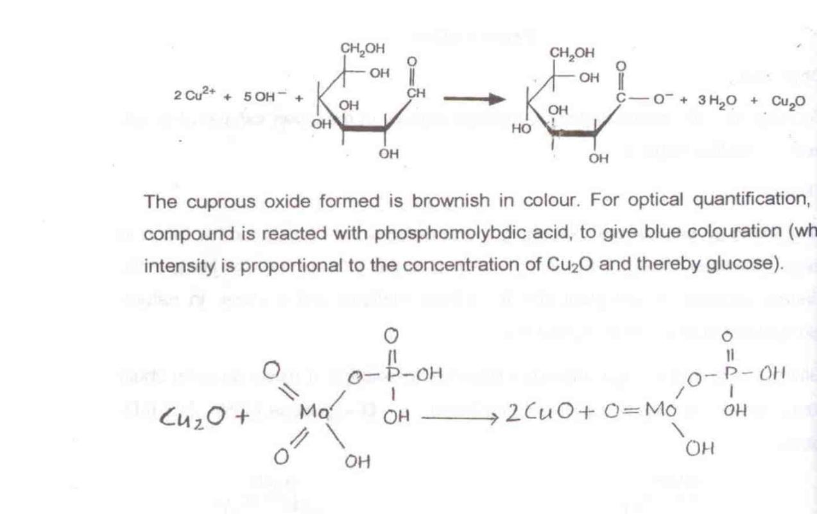

The cuprous oxide formed is brownish in colour. For optical quantification, this compound is reacted with phosphomolybdic acid, to give blue colouration  (whose intensity is proportional to the concentration of Cu2O and thereby glucose.

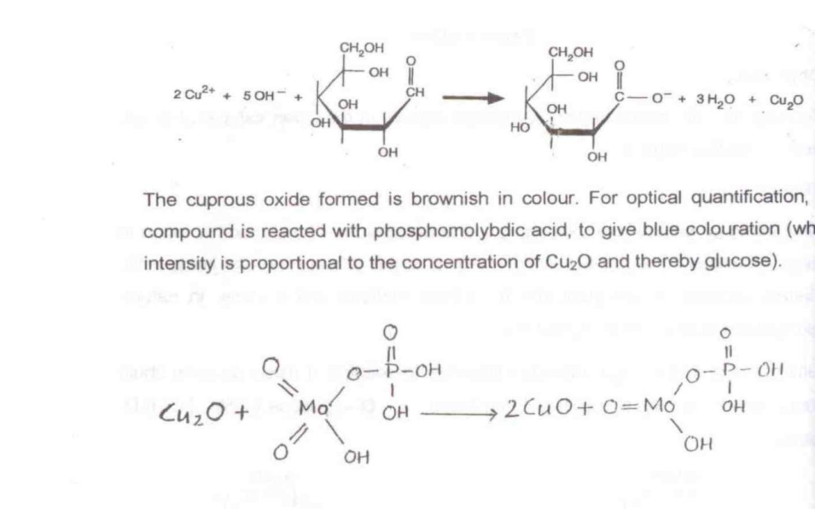

The oxidizing agent used here is tartrate complex of alkaline copper (II) sulphate, known as Fehling’s solution. A precaution needs to be taken when used with blood, since it reacts with blood proteins and may give false results. Blood is deprotenized (using tunsgtic acid) before use.

Glucose is the primary source of energy in most organisms. It is broken down stepwise (during the processes of glycolysis and Kreb’s cycle) to give CO2 and water, and 7300 kcal of energy per mole. Excess glucose is stored as glycogen in animals and as starch in plants. In man, a constant level of glucose is maintained in blood by the interplay of hormones such as insulin glucagons and epinephrine.

Glucose determination is mainly useful in the diagnoses of diabetes mellitus, the condition in which blood glucose levels are elevated (hyperglycemia). Other diseases like hyperthyroidism and hyperpituitarism also lead to hyperglycemia, Hypoglycemia occurs frequently as a result of overdosage of insulin anti-diabetes treatment. If untreated, it may lead to coma.

Yet another method of  glucose estimation, which is more rapid than Fdin-Wu’s, is the GOD/POD method. Here, glucose oxidase (GOD) is the oxidizing agent, peroxidase (POD) catalyzes the subsequent reaction to produce red coloration.

**Requirements:**

**a.** Alkaline copper sulphate solution:

                   Reagent A: 2% Na2CO3 in 0.1N NaOH.

                    Reagent B: 0.5%CuSO4 IN 1% Sodium potassium tartrate.

                   Reagent C: Alkaline copper sulphate solution: Mix 50 ml of reagent A

with 1.0ml of reagent B prepared fresh.

**b.** Phosphomolydic acid:

                  Take 35gm molybdic acid

                  5mg Na-Tungstate

                  200ml NaOH (1%)

                  100ml water

Boil for 30-45 minutes vigorously. Cool and make-up to 350 ml by adding distilled water. Now add 125 ml of 85% phosphoric acid and make up the volume to 500ml.

**c.** Glucose standard 100mg/100ml

**d.** Sodium Tungstate 10mg/199ml

**e.** Sulfuric acid = N/12(2.3ml of conc. H2SO4 in 999.7ml of water)

**Procedure:**

1. Take 5test tubes and mark them asB, S1, S2, S3, S4 and T(B=Blank, S=Standard and T=Test solutions). Fill in these test tubes in the following way:

|  | B | S1 | S2 | S3 | S4 | T |
| --- | --- | --- | --- | --- | --- | --- |
| Standard solution | -- | 0.50 | 1.00 | 1.50 | 2.00 | -- |
| Water | 2.00 | 1.50 | 1.00 | 0.50 | -- | -- |
| Test solution | -- | -- | -- | -- | -- | 2.00 |
| Concentration (mg/100ml) | 0.00 | 25.00 | 50.00 | 75.00 | 100.00 | ? |

1. Add 2ml of alkaline copper solution in each tube and keep in a boiling water bath for 6 minutes.
2. Cool the tubes under tap water and add 2ml of phosphomolybdic acid solution to all the tubes.
3. Mix the contents by gentle shaking and optical density at wavelength of 420nm. Use blank solution to adjust zero setting on the instrument

**Observation:**

1. Record the optical density in the following table:

| Tube | B | S1 | S2 | S3 | S4 | T |
| --- | --- | --- | --- | --- | --- | --- |
| OD420 |  |  |  |  |  |  |

1. Prepare standard curve and match the optical density of the test sample. The corresponding concentration on x-axis will give the concentration of glucose present in blood.

**Result:**

The concentration of glucose (mg/ml) of blood was found to be ___________.

**Marks Obtained:**

**Signature of Instructor:**

**Review Questions:**

1. What is the role of heat treatment at 800 C in glucose estimation from blood serum by Folin Wu’s method?
2. What is the normal concentration of blood sugar in human body?
3. How the level of sugar in vertebrate blood kept constant?
4. Why glucose alone is used for intravenous infusion, not fructose or sucrose?
5. What is the difference between a reducing and non reducing sugar?

**EXPERIMENT 3**

**Objective:**

To determine the ‘Mitotic-index’ and duration of mitosis in the given plant tissue.

**Theory:**

Mitosis is somatic cell division. The cell division takes place in two stages; karyokinesis (division of cell nucleus) and cytokinesis (division of the cytoplasmic contents). The karyokinesis is sub-divided into four phases: prophase, metaphase, anaphase and telophase.

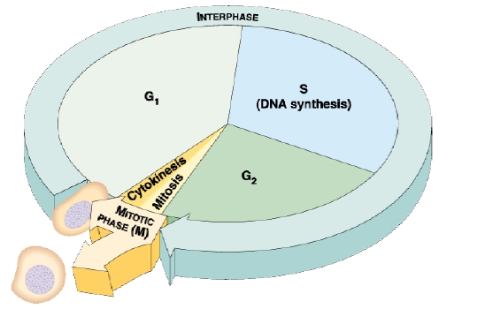

In any mitotically active cell population, only some cells are in the dividing phase (karyokinesis) at any given time, while other cells are in interphase (non dividing phase). The cell cycle involves the following:

* Interphase - The period of time when a cell undergoes its normal activities, including
  + Growth (called G1 or First Gap in the cell cycle)
  + DNA Replication (called S for synthesis in the cell cycle)
  + Preparation for Division (called G2)
* Cell Division (or cell reproduction), which includes
  + Mitosis,
  + Cytokinesis

**The Phases of Mitosis and the Cell Cycle are:**

**Interphase**

Most of the cells of the meristem will be in interphase. The granular chromatin material in the nucleus is distinctive although no individual chromosomes are visible. You may also see the nucleoli. DNA replication occurs during interphase.

**Prophase and Prometaphase**

Replicated chromosomes condense from the diffuse chromatin and become visible as threadlike structures. Each replicated chromosome is composed of its two identical replicas (called chromatids) held together at their centromere. Replicated chromosomes continue to condense and become thicker as prophase progresses. The **nucleolus** region (an aggregation of chromosome bits and concentrated RNA and protein) of the nucleus will start to disappear. The replicated chromosomes are firmly attached at their centromeres throughout this condensation and coiling. Microtubules and associated proteins initiate **spindle** formation during prophase. The spindle apparatus originates from a **microtubule organizing center**, also called the **centrosome**. The centrosome is self-replicating and replicates during interphase. In animal cells, **centrioles** are found within the centrosome, but not in cells of higher plants, including the onion. Microtubules radiating from the centrosomes are called **asters**.

By the end of prophase (often separated into a phase called **prometaphase**), the spindle apparatus will extend from the poles of the cell through the center of the cell to the opposite pole of the cell. Some microtubules from each pole of the cell attach to a protein structure, called the **kinetochore,** located in the centromere region of each replicated chromosome.

The nuclear membrane degrades in **prometaphase** (or late prophase) into small

vesicles that will be used to synthesize new nuclear membrane material in the new

cells.

**Metaphase**

The spindle apparatus has moved the chromosomes to the equator of the cell, aligning the centromeres of each replicated chromosome along the equator. Centromeres of each sister chromatid are aligned with each other and each sister chromatid is connected at its kinetochore to a microtubule. This alignment of chromosomes along the equatorial plane of the cell is often called the **metaphase plate or equatorial plate**, and is the distinctive feature of metaphase.

**Anaphase**

Centromeres of each replicated chromosome separate to start anaphase. (This also

signals that metaphase has been completed.) By definition, each sister chromatid is now a single unreplicated chromosome. Microtubules from each pole pull the chromosomes away from each other and toward the respective poles of the cell. Each of the two clusters of chromosomes being pulled to the two poles of the cell has one copy of each original chromosome.

**Telophase**

Membrane vesicles and membrane fragments form new nuclear membranes around each group of separated chromosomes at the poles of the cell. Chromosomes stretch back out and become indistinct as chromatin. The spindle microtubules disperse and the spindle apparatus disappears. New nucleoli form. At the completion of telophase, there will be two new nuclei, each identical to the original nucleus.

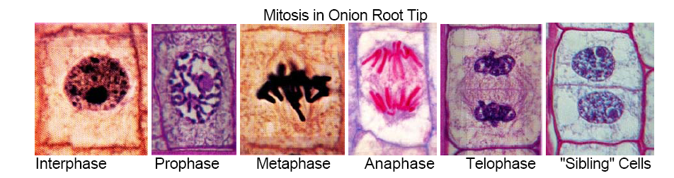

**Mitotic index**

The fraction or percentage of dividing cells is defined as the mitotic index (MI). MI is important to determine the duration of mitosis in the cell cycle of growing tissues/cell and also for scaling up cultures for various biotechnology purposes.

To obtain MI, one should examine a mitotically active cell population e.g. growing root-tips of *Allium cepa* (Onion). The mitotic stages are generally studied by squash preparation.

**Microscope Design**:

Microscopes are indispensable in biological studies. The human eye has some intrinsic limitations as a magnifying instrument, the eye cannot focus on objects closer to approximately 25 cm. This is the distance of maximal effective magnification. To be visible, an object must also subtend to an angle of 1 or greater at the eye.

As can be seen from the figure, the compound microscope consists of three lenses: the objective lens, the condenser lens and the eyepiece (ocular) lens. The specimen is mounted on a stage that can be moved at right angles to the microscope axis, which is also referred to at the z axis. The light source is focused by adjusting the condenser lens, which is rigidly connected by the microscope column. Focusing of the specimen is done by adjusting the distance between specimen and the objective.

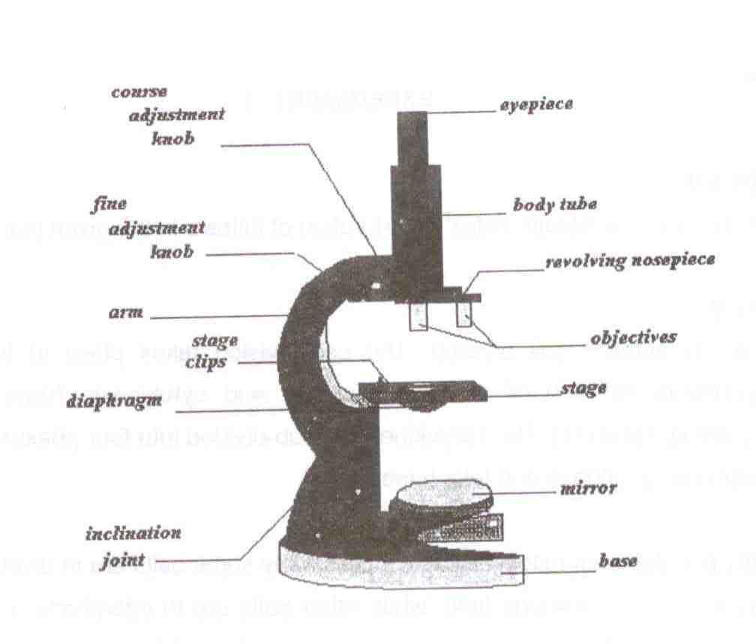

**Working Principle of Microscope:**

The principle function of a microscope is thus magnification. In other words the microscope increases the apparent angle subtended at the eye by objects within the microscopic field. The property of a microscope is quantified as the magnification (M).

Resolving power specifies the smallest detail that the microscope can resolve in imaging an ideal specimen. The distance between two points in the microscopic field that can just be distinguished from one another is called the minimum resolvable distance, d min. This is defined by the equation

0.5 

d min= ------------

N sin

● : Wavelength of the light source

 : the aperture angle of the objective lens N : the refractive index of the medium between the specimen and the objective lens

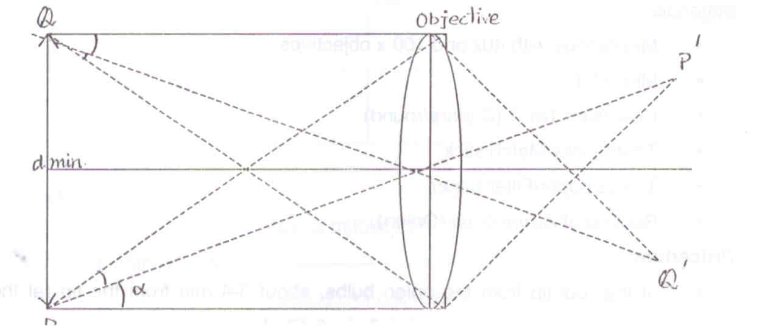

In order to be visible through a microscope an object must possess a certain degree of contrast with its surrounding medium. This contrast is a result of the fact that less light is transmitted through the object then through medium. This decreased light transmission is caused by two factor:- light absorbed by the object and light refracted out of the optical path of the microscope, by a difference in the refractive index between the object and the surrounding medium. Contrast can be greatly increased by staining procedures: treatment with eyes that bind selectively either to the whole cell **or to certain cell components, thus producing a much greater absorption or light.**

Thus we see that magnification, resolution and contrast are three important factors in microscopy.

Requirements:

Reagents:

1. 10% Hydrochloric Acid- Take 9 ml water and add 1ml HCl to it slowly.
2. Acetocramine Stain- Mix 90ml Acetic acid with 110ml distilled water (45%Acetic acid). Add 2gm carmine to 100ml of 45% acetic acid and boil for 30 mins. Cool and makeup the volume of filtered stain to 100ml by adding 45% acetic acid. Filter and store.
3. Farmer’s Fixative- Mix absolute Alcohol and Glacial acetic acid in the ratio 3:1.
4. Glycerin/Liquid paraffin.

**Materials**: Microscope with 40xand 100x objectives

Glass Microslides

Coverslips No.1(Square/round)

Tooth-picks/Match Sticks

Tissue paper/Filter paper

Root-tip of *Allium cepa* (Onion)

**Procedure:**

1. Cut the root tip from the onion bulbs, about 3-4mm from the tip (at the base of meristem) and rinse briefly in distilled water.
2. Place the tip in 10% HCl (V/V) for 5min at room temperature and again rinse in distilled water.
3. Stain the tip in acetocarmine solution for 5min and rinse again in distilled water.
4. Place the stained tip in a drop of water on a microslide and cover with a coverslip.
5. Gently tap the root-tissue with the flat end of a glass-root/tooth pick/match stick to produce a squash having homogenous cell suspension. Do not tap hard on the coverslip, it may break.
6. Remove excess liquid from under the cover slip by placing tissue paper/filter paper over the cover slip and press gently with index finger. Seal the edges with glycerine/liquid paraffin.
7. Examine under the microscope.

**Observation:**

Count the number of mitotic and interphase cells under the Microscope at 10x40 magnification from at least three different places.

|  | **No. of Cells** | | | |
| --- | --- | --- | --- | --- |
| **Cell Type** | **Site I** | **Site II** | **Site III** | **Total** |
| 1. **Mitotic Cell** |  |  |  |  |
| 1. **Interphase Cell** |  |  |  |  |

**Calculation:**

No. of mitotic cells

1. Mitotic index = —----------------------------- = frequency of mitotic cell

Total No. of cell counted

2. Duration of Mitosis =Mitotic index x duration of cell cycle

(Given that the cell cycle is of 19 hr duration).

**Results:**

Mitotic index =

Mitotic Duration=

**Marks Obtained:**

**Signature of the Instructor:**

**Review Questions:**

1. In the mitotic index experiment, which dye is used for staining the nucleus?

2. Why only root of Alium cepa is used for the experiment, but not any other parts?

3. What is the difference between the prophase of mitosis and meiosis?

4. Why do interphase cells does not show any chromosomes?

5. Why are the root tips placed in 10% HCl?

**EXPERIMENT 4**

**Objective:**

To conduct experiment on blood for-

A.        Hemoglobin content                   B.     ABO-Rh Blood typing

**A. Hemoglobin content**

**Theory:**

The blood serves as a principal medium in the body to carry oxygen, nutrients and chemical messages to the tissues, to clear waste products and to synthesize metabolites away. It carries the hormones for activation of various tissues, aids in defense of the body, maintenance of osmotic pressure, pH, and temperature equilibrium in tissue of the body. Thus blood plays an important role in coordinating the individual cell into a whole complex organism.

The amount of oxygen that can be carried in sample solution is small, however many highly organized animals (vertebrates almost without exceptions) have blood that can bind larger quantities of oxygen reversibly, thus greatly increasing the amount of oxygen carried. In mammalian blood, the amount of physically dissolved oxygen is about 0.2 ml O2 per 100ml blood, and amount bound reversible to hemoglobin; the red colored respiratory pigment, is up to some 100 times as great, about 20 ml O2 per 100ml blood.

Hemoglobin is the most widespread and best known respiratory pigment. It consists of a protein molecule associated with a four-membered ring structure known as a porphyrin. The iron that each hemoglobin molecule contains is bound to the porphyrin with one atom of divalent iron (Fe2+) attached to each porphyrin unit.

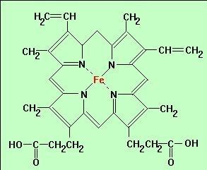

All mammalian hemoglobin have molecular weight of approximately 65,000 dalton and are made up of peptide chains to each of which is bound a heme. Normal human beings synthesize and incorporate hemoglobin into four distinct but related polypeptide chains as α, β, γ and δ. With few exceptions, hemoglobin molecules are constructed by combining two α chains with two β, γ or δ chains.

When the hemoglobin in the blood is treated with N/10 HCl, the hemoglobin is converted into hematinic acid (brown in colour) which is compared with standard hematin by the hemometer .The percentage of hemoglobin in the RBC under normal condition almost constant. In few diseases such as anemia, the hemoglobin percentage declines due to loss of hemoglobin from the RBC or by disintegration of RBC themselves. In men the hemoglobin is about 15.8gms while in women it is approximately 13.7gms in 100ml of blood.

**Requirements:**

1. Sahli’s haemoglobinometer or Gower’s Haldane hemoglobinometer or hemometer. This instrument consists of-
2. Two tubes which have standard colour for comparing the tinge of human blood hemoglobin tube are graduated on two sides. On one side, it indicates percentage and on other side it gives gm percentage.
3. The Pasteur pipette, which is marked at 20cm in the middle and connected to a sucking tube.
4. Dropper
5. N/10 HCl solution
6. Distilled water
7. Fresh blood

**Procedure:**

1. The apparatus should be clean and dry before used for the estimation of hemoglobin.
2. Take hemoglobin tube; fill it by N/10 HCl upto 2 cm mark on gram percentage side.
3. Prick your left hand finger by a sterilized needle/lancet after cleaning with spirit or 70% alcohol and suck the blood in pasture pipette upto 20 cm mark, wipe off the excess blood attached to tip of the pipette.
4. Dip the pipette tip in the N/10 HCl of hemoglobin tube and discharge the blood into it.
5. Shake it thoroughly with a glass rod. Observe the colour of brown solution.
6. Add distilled water drop by drop to solution until the colour of the blood solution resembles perfectly with the colour of the standard tubes. The colour can be compared by keeping the hemoglobin tube in the hemometer between two standard colour tubes (space provide).
7. Remove the hemoglobin tube from the hemometer and note the reading in gram percentage or percentage directly.

**Observation:**

The reading should be taken only when the colour of the blood solution resembles perfectly with the colour of the standard tube of hemoglobinometer.

**Result:**

Hemoglobin content of the blood sample is ------------ %.

**B. Human ABO Blood Typing:**

**Theory:**

The biological uniqueness that each individual attains is frequently noted in the reaction that occurs when an organism receives biological material from other organism. In animals the tissues that are removed from one individual and grafted to another are frequently slough off or rejected because of incompatibility between the introduced material and that of host. ABO Blood typing is an excellent example of the serological principal of agglutination. Around the turn of century it was determined by Karl Landsteiner that there were four different immunological human blood types. This theory was based on the fact that two distinct antigens (agglutinogens), A and B, could be present on the surface of RBC’s. Depending on the presence or absence of either or both the antigens, blood types were established: A, B, AB, or O. They constitute the ABO classification system as illustrated in the table-

| **RBC antigen**  **(agglutinogen)** | **Plasma antibodies**  **(agglutinins**) | **Blood Group** |
| --- | --- | --- |
| A | Anti-B | A |
| B | Anti-A | B |
| A and B | None | AB |
| None | Anti-A and Anti-B | O |

of medical importance is the fact that fluid portion of the blood, the plasma may contain antibodies (agglutinins). If present, these antibodies are not reactive against the individual’s own RBC’s. When mixed with the red-blood cells antigens of a different blood type, however, as during the course of a blood transfusion, a violent, incompatible agglutination reaction may result. Thus ABO blood typing is a routine prerequisite to blood transfusions.

**Rh Factor from human blood**

K.Landsteiner and S. Weiener discovered the Rh factor in 1940 from rabbits immunized with the blood of the monkey, *Rhesus macaca*. The resulting antibodies were found to agglutinate not only the RBC’s of monkey but those of the high percentage of human population also. Individual whose antigen react with Rh antibody are termed Rh positive if not termed Rh negative. The symbol Rh came from the first two letter of the species name of the monkey. A test for Rh incompatibility is accomplished by placing a drop of blood from the subject on a slide and introducing anti-Rh serum. Agglutination of erythrocytes indicates incompatibility, whereas an even distribution of erythrocytes indicates no reaction.

The original antigen, now symbolized Rho is highly antigen to human. Thus cross-matching of Rh factor, as well as ABO types of donor and recipient blood, is now using to avoid incompatibility agglutination reactions following transfusions. Blood is frequently exchanged between the mother and the fetus during childbirth. Thus, Rh-negative mother are often immunized by blood from Rh-positive fetuses (which may result when the father are Rh-positive) to which they give birth. Usually no ill effects are associated with the exposure of the mother to the Rh-positive antigen during the first childbirth (unless the mother has been previously exposed to Rh antigen by transfusion). Subsequent Rh positive children carried by the same mother against the Rh antigen, which are carried across the placenta in blood serum. Such children may develop symptoms of hemolytic jaundice and anemia, a condition referred to as erythroblastosis fetalis. The symptoms may be mild or severe, even resulting in the death of the fetus or new born infants if appropriate steps are not taken by the physician.

In the experiment to follow, students will perform an ABO blood typing procedure by separately mixing a drop of their blood with anti-A, anti-B and anti-D sera on a glass slide. The determination of blood type is made by observing for agglutination on the slide preparation as illustrated in Figure-

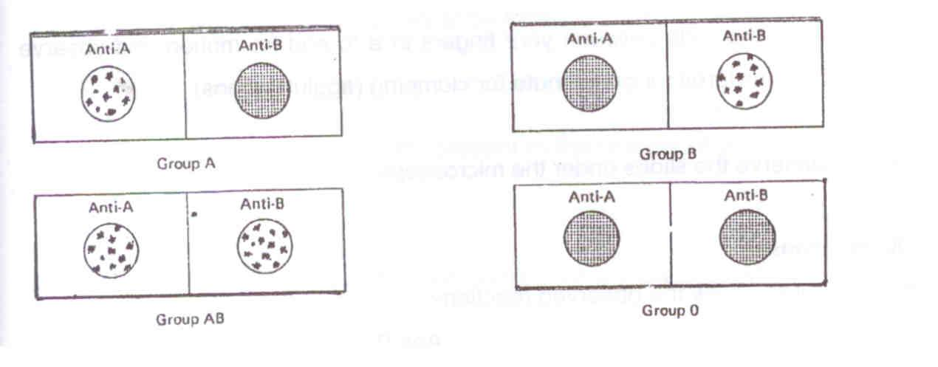

**Requirements:**

1. Anti-A, Anti-B and Anti-D blood typing sera and 70% alcohol.
2. Microscopic slides, sterile blood lancets, absorbent cotton, wooden applicator sticks and wax pencils.

**Procedure:**

1. Using a wax pencil, mark microscope slide in half. Label one side as anti-A and the other side as anti-B.
2. Take another slide and mark it as anti-D
3. Place one drop of each antiserum on the appropriately labeled section of the slides
4. Using a piece of absorbent cotton moistened with 70% ethyl alcohol; wipe the tip of the middle finger.
5. Using a sterile lancet, prick the disinfected area of the finger.
6. Allow one drop of blood to flow into each of the antiserum on the slides.
7. With separate applicator sticks, mix each drop of blood with its respective antiserum.
8. Rock the slide between your fingers in a to and fro motion and observe both mixtures for one minute for clumping (agglutinations).
9. Observe the slides under the microscope

**Observations:**

In the diagram, draw the observed reaction-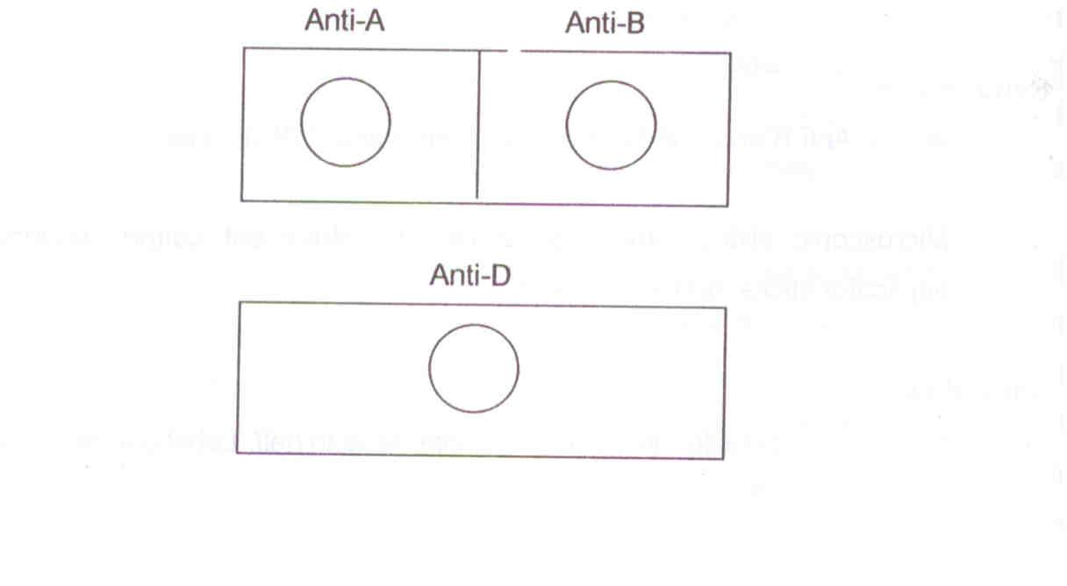

**Results**

1. Determine and indicate the ABO blood type _________________
2. Indicate the agglutinogen present ________________
3. Indicate the agglutinin present _________________
4. Determine and indicate the Rh type __________________

**Marks obtained:**

**Signature of instructor:**

**Review questions:**

1. Explain why type B blood cannot be transfused into a person with type A blood?
2. Why there are no agglutinins present in the plasma of an individual with type AB blood?
3. Can blood typing be performed using only the serum portion of blood? Explain
4. What happens to the red blood cells when they are kept in 75mM NaCl, 150mM NaCl and in distilled water?
5. What is the significance of hematinic acid in hemoglobin estimation?
6. Why hemoglobin content is more in males than in females?
7. Explain why type B blood cannot be transfused into a person with type A blood?
8. Why are there no agglutinins present in the plasma of an individual with type AB blood?
9. Can blood typing be performed using only the serum portion of blood? Explain
10. What happens to the red blood cells when they are kept in 75mM NaCl, 150mM NaCl and in distilled water?
11. What is the significance of hematinic acid in hemoglobin estimation?
12. Why hemoglobin content is more in males than in females?

**EXPERIMENT 5**

**Objective:**

Quantitation of DNA

**Theory:**

# The Double Helix

The double helix of DNA has these features:

* It contains two polynucleotide strands wound around each other.
* The backbone of each consists of alternating [deoxyribose](http://users.rcn.com/jkimball.ma.ultranet/BiologyPages/N/Nucleotides.html) and [phosphate groups](http://users.rcn.com/jkimball.ma.ultranet/BiologyPages/P/Phosphate.gif).
* The phosphate group bonded to the 5' carbon atom of one deoxyribose is covalently bonded to the 3' carbon of the next.
* The two strands are "antiparallel"; that is, one strand runs 5′ to 3′ while the other runs 3′ to 5′.
* The DNA strands are assembled in the 5′ to 3′ direction and, by convention, we "read" them the same way.
* The [purine](http://users.rcn.com/jkimball.ma.ultranet/BiologyPages/P/Purines.gif) or [pyrimidine](http://users.rcn.com/jkimball.ma.ultranet/BiologyPages/P/Pyrimidines.gif) attached to each deoxyribose projects in toward the axis of the helix.
* Each base forms [hydrogen bonds](http://users.rcn.com/jkimball.ma.ultranet/BiologyPages/H/HydrogenBonds.html) with the one directly opposite it, forming **base pairs** (also called nucleotide pairs).
* 3.4 Å separates the plane in which adjacent base pairs are located.
* The double helix makes a complete turn in just over 10 nucleotide pairs, so each turn takes a little more (35.7 Å to be exact) than the 34 Å shown in the diagram.
* There is an average of 25 hydrogen bonds
* Within each complete turn of the double helix providing a stability of binding about as strong as what a [covalent bond](http://users.rcn.com/jkimball.ma.ultranet/BiologyPages/E/Electronegativity.html#covalent_bond) would provide.
* The diameter of the helix is 20 Å.
* The helix can be virtually any length; when fully stretched, some DNA molecules are as much as 5 cm (2 inches!) long.
* The path taken by the two backbones forms a major (wider) groove (from "34 A" to the top of the arrow) and a minor (narrower) groove (the one below).

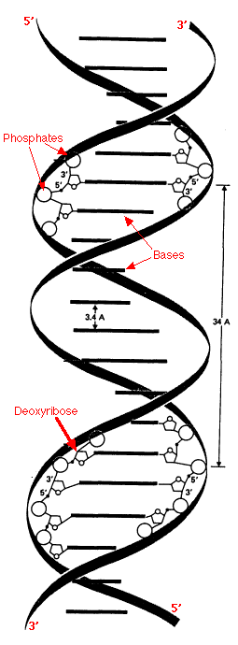

Principle of isolation

* To extract DNA from the cells require disrupting the cell membrane by using liquid detergent. In case of plants, cell wall also has to be removed by giving an osmotic shock using NaCl.
* The histone proteins associated with DNA are removed by using pineapple juice that has proteases.
* DNA is extracted with the help of absolute alcohol which reduces the dielectric constant of the DNA that precipitates out of solution by forming a spool.
* The spool is spun down and then visualized by dissolving in water or Tris EDTA buffer as DNA is soluble in aqueous buffer.
* The dye Ethidium bromide **intercalates** between the nitrogenous bases and fluoresces when exposed to UV light to help to quantify the DNA.

**Requirements:**

Green peas

Table salt

Cold water

Liquid detergent

Meat tenderizer / pineapple juice

70-95% ethanol

TE buffer: 10mM Tris-HCl, pH 7.5, 1mM EDTA

Agarose: Dissolve 1gm of agarose in distilled water and pour on glass slides.

**Procedure:**

**Extraction of DNA**:

1. Take 10gm of green peas along with 0.5 gm of table salt and 20ml of distilled water in mortar and pestle.
2. Grind well and pour the thin pea soup into another container through a strainer.
3. Add about 20ml of liquid detergent and swirl to mix.
4. Let the mixture sit for 5 – 10 minutes.
5. Distribute the upper aqueous part into test tubes about 1/3rd full.
6. Add 1ml of meat tenderizer / pineapple juice to the different test tubes and invert the tubes gently. NOTE: Don’t stir too hard, you might break up the DNA.
7. Tilt the test tube and add equal amount of 70-95% chilled ethanol/isopropyl alcohol along the side of the test tube so that it forms a layer on top of the pea mixture.
8. DNA will rise into the alcohol layer from the pea layer.
9. Spool the DNA and centrifuge at 3000 rpm for 10 minutes, discard the upper aqueous layer and dissolve the pellet in TE buffer with Ethidium Bromide (1 µg/ml)

**Quantitation of DNA:**

*Fluorescence quantitation*

1. Spot 10 µl of sample on different parts of an Ethidium Bromide Agarose (as a gel plate).
2. Also spot on the plate 10 µl of at least 10, 20 and 40 µg/ml of DNA standard.
3. Let the liquid soak in and invert the plate on the transilluminator and compare, interpolate and record the unknown spots for fluorescent intensity to the standard.
4. Calculate the amount of DNA by comparing with the standards.

**Observation**

*Fluorescence Quantitation:*

| Tube Number | Concentration of DNA |
| --- | --- |
| S1 |  |
| S2 |  |
| S3 |  |
| T |  |

**Result:**

The DNA concentration in the extracted sample is _______________µg/ml

**\Marks obtained:**

**Signature of instructor:**

**Review of questions:**

* 1. What type of technology helped to show that DNA was shaped like a twisted ladder?
  2. What part of the molecule forms the rungs of the ladder?
  3. What part of the molecule forms the sides of the ladder?
  4. How does a three-letter code make it possible to make 64 different combinations?
  5. Why was it believed that it was necessary to have a three-letter code?
  6. What is a codon?
  7. What types of DNA mutations can occur?
  8. What are the possible results of DNA mutations?
  9. What is the difference between the conserved strand of DNA and the complementary strand?

**EXPERIMENT 6**

**Objective:**

To determine Vmax and Km of phosphatase enzyme from mung (green gram) seedlings.

**Theory:** Enzymes promote both synthesis and breakdown of biological molecules as well as a range of other molecular processes. They are sensitive to a variety of substances that modify or inhibit their action, including the products of the reactions they catalyze.   
Study of the impact made on the rate of an enzyme-catalysed reaction by changes in experimental conditions is known as **enzyme kinetics**. Knowledge of kinetics can be a very useful tool in understanding the **mechanism** by which an enzyme carries out its catalyticactivity   
   
The effect of substrate concentration on the initial rate of an enzyme-catalysed reaction is a central concept in enzyme kinetics. When data are generated from experiments of this type and the results plotted as a graph of initial rate (**v, y-axis**) against substrate concentration (**[S]** \***, x-axis**), many enzymes exhibit a rectangular hyperbolic curve like the one shown in the diagram below.

| michgraph |
| --- |

Observations of this type set Leonor Michaelis and Maud Menten thinking about the underlying reasons why a curve should follow this shape and led them to derive an algebraic equation that now bears their names.    
  
**Derivation**  
Start with the generalised scheme for enzyme-catalyzed production of a product (P) from substrate (S). The enzyme (E) does not magically convert S into P, it must first come into physical contact with it, i.e. E binds S to form an enzyme-substrate complex (ES).  Michaelis and Menten therefore set out the following scheme:

mich55

The terms k1, k-1 and k2 are rate constants for, respectively, the association of substrate and enzyme, the dissociation of unaltered substrate from the enzyme and the dissociation of product (= altered substrate) from the enzyme.  Note that there is the theoretical possibility of a reverse reaction, with ES complex forming from E and P, but this can be ignored because we are considering *initial* rates of reaction, i.e. when the enzyme is first provided with substrate, so there should not be any product available to combine with enzyme.

The overall rate of the reaction (v) is limited by the step ES to E + P, and this will depend on two factors - the rate of that step (i.e. k2) and the concentration of enzyme that has substrate bound, i.e. [ES].  This can be written as:

mich66(Equation 1)

At this point it is important to draw your attention to two assumptions that are made in this scheme.  The first is the availability of a vast excess of substrate, so that [S]>>[E].  Secondly, it is assumed that the system is in steady-state, i.e. that the ES complex is being formed and broken down at the same rate, so that overall [ES] is constant.  The formation of ES will depend on the rate constant K1 and the availability of enzyme and substrate, i.e. [E] and [S].  The breakdown of [ES] can occur in two ways, either the conversion of substrate to product or the non-reactive dissociation of substrate from the complex.  In both instances the [ES] will be significant.  Thus, at steady state we can write:

mich44

The next couple of steps are rearrangements of this equation.  First of all we can collect together the rate constants on the right-hand side because they are both multiplied by [ES], this gives us:

mich77

Then dividing both sides by (k-1 + k2), this becomes:

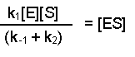

Notice that the three rate constants are now on the same side of the equation.  As the name implies, these terms are constants, so we can actually combine them into one term.  This new constant is termed the Michaelis constant and is written KM.

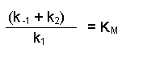

Notice that the three rate constants in the definition of KM are actually inverted (the other way up) compared with our previous equation.  This is a 'trick' that makes for easier calculation at a later stage.  Substituting this definition of KM into our previous equation now gives us:

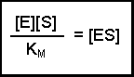(Equation 2)

The total amount of enzyme in the system must be the same throughout the experiment, but it can either be free (unbound) E or in complex with substrate, ES.  If we term the total enzyme E0, this relationship can be written out:

michme9

This can be rearranged (by subtracting [ES] from each side) to give:

michme10

So, the [E] free in solution is equal to the total amount of enzyme minus the amount that has substrate bound.  Substituting this definition of [E] back into equation 2 gives us:

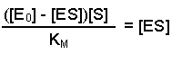

This can now be rearranged in to several steps.  First of all, open the bracket so that the terms [E0] and [ES] are separately multiplied by [S]

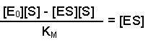

Next, multiply each side by KM, this gives us:

michme13

Then collect the two [ES] terms together on the same side (you can either think of this as adding [ES][S] to both sides or as 'carry over and change the sign').  This gives:

michme14

Then because both terms on the right-hand side are multiplied by [ES] we can collect them together into a bracket:

michme16

Dividing both sides by (KM + [S]) now gives us:

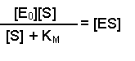

Substituting this left-hand side into Equation 1 in place of [ES] results in:

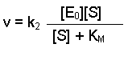

The maximum rate, which we can call Vmax, would be achieved when all of the enzyme molecules have substrate bound.  Under conditions when [S] is much greater than [E], it is fair to assume that all E will be in the form ES.  Therefore [E0] = [ES].  Thinking again about Equation 1, we could substitute the term Vmax for v and [E0] for [ES].  This would give us:

mich33

Notice that k2[E0] was present in our previous equation, so we can replace this with Vmax, giving a final equation:

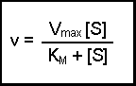

This final equation is actually called the Michaelis-Menten equation.

 The significance becomes clearer when you consider the case when the rate of reaction (v) is exactly half of the maximal reaction rate (Vmax).  Under those circumstances, the Michaelis-Menten equation could be written:

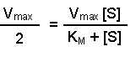

On dividing both sides by Vmax this becomes:

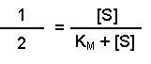

Multiplying both sides by (KM + [S]) gives:

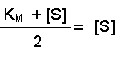

And then multiplying both sides by 2, further resolves the equation to:

michme3

2[S] on the right-hand side is the same as [S] + [S], so we can take away one [S] from each side.  Thus when the rate of the reaction is half of the maximum rate:

michme4

The KM of an enzyme is therefore the substrate concentration at which the reaction occurs at half of the maximum rate.  If we now reconsider the graph that came at the start of this theory it could be written:

| vmaxgraph |
| --- |

What does this all mean in physical terms?  KM is an indicator of the affinity that an enzyme has for a given substrate, and hence the stability of the enzyme-substrate complex.

Look at the shape of the graph.  At low [S], it is the availability of substrate that is the limiting factor.  Therefore as more substrate is added there is a rapid increase in the initial rate of the reaction - any substrate is rapidly mopped up and converted to product.  At the KM, 50% of active sites have substrate bound.  At higher [S] a point is reached (at least theoretically) where the entire enzyme has substrate bound and is working flat out.  Adding more substrate will not increase the rate of the reaction, hence the leveling out observed in the graph.

**Phosphatase enzyme**

We will be studying enzyme kinetic of phosphatase. Phosphatase enzymes occur in a wide range of plant and animal tissues. They catalyze the hydrolysis of phosphate bonds in organic phosphates, between the phosphate group and the rest of the molecule. This releases phosphate ions from a variety of phosphate substrates into the metabolic pool.

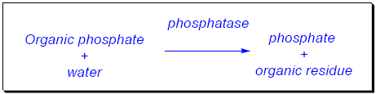

Phosphate is an essential component of a number of biologically important molecules, including DNA and RNA, phospholipids of cell membranes, ATP and many metabolites. Phosphatases are key enzymes in liberating and recycling the phosphate that is necessary for many fundamental biological processes. A range of research interests focus on phosphatases. They have, for example, been implicated in such diverse roles as possible allergens in part of the protein coat of pollen grains and as markers of abnormal prostate gland function.

This protocol uses **phenolphthalein phosphate (PPP)** as an *artificial* substrate. You may already be familiar with **phenolphthalein**, which is used as an indicator. Phenolphthalein goes from colourless to magenta as the solution becomes more alkaline (pH 8.3 to 10.0). Its phosphate salt (PPP) is colourless in alkaline solution, but when the phosphate is removed, the magenta colour of alkaline phenolphthalein is observed.

In this protocol, PPP is incubated with a phosphatase enzyme to remove the phosphate and release phenolphthalein. Sodium carbonate is added at the end of the incubation to stop the reaction. The sodium carbonate increases the pH to 9.5 and any free phenolphthalein then gives a magenta color.

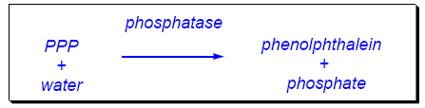

The PPP and enzyme are incubated for a given time under appropriate experimental conditions. The intensity of colour produced (after addition of sodium carbonate solution) is proportional to the concentration of phenolphthalein, and so gives a measure of the level of enzyme activity.

**Requirements**

Mung seedlings (Removed 5 day old)

1% phenolphthalein phosphate

10% Sodium carbonate solution

**Procedure:**

1. Grind 5 gms of mung seedlings to a paste with 30ml of distilled water. ( Removed 2nd point that is filter with muslin cloth)
2. Centrifuge at 3000rpm for 10 minutes.
3. Supernatant will serve as enzyme solution.
4. Prepare the following test tubes

| Volume of 1% Phenolphthalein phosphate (ml) | Volume of distilled water (ml) |
| --- | --- |
| 1. (Blank) 2. 0.1 3. 0.2 4. 0.3 5. 0.4 6. 0.5 7. 0.6 | 1.0  0.9  0.8  0.7  0.6  0.5  0.4 |

1. Add 1.5ml of enzyme solution in each tube and leave them undisturbed for 15 minutes.

1. The following reaction occurs

phenolphthalein ---------------------------------------> free phenolphthalein

phosphate (phosphatase enzyme) + phosphate

1. Add 5ml of 10% Sodium carbonate solution and invert the tube to mix.
2. The addition of sodium carbonate solution stops the reaction and, if free phenolphthalein is present, a pink colour is seen.
3. Measure the absorbance at 600nm using a blank with distilled water in place of the supernatant.
4. Plot a graph of substrate concentration [s] vs rate of reaction [v] and find out Vmax and Km from it

**Observation:**

| Phenolphthalein phosphate conc. | Absorbance |
| --- | --- |
|  |  |

**Results:**

The Vmax and Km for the phosphatase enzyme from mung seedlings respectively are ________________________ and _____________________.

**Marks Obtained:**

**Signature of the instructor:**

**Review Questions:**

1. What is the effect of pH on the activity of the enzyme?
2. Where in the plant is most enzyme located?
3. What is the effect of varying enzyme concentrations and substrate concentrations?
4. What is the relevance of KM measurements in drug discovery industry

**EXPERIMENT No. 7**

**OBJECTIVE**Separation of chlorophyll pigments by paper chromatography.

**THEORY**The means to carry out photosynthesis in plants is the green pigment chlorophyll. A whole series of chlorophylls called C*hl* a, b, c, d and e is known.

Chlorophyll a is the primary photosynthetic pigment and is found widely distributed in the plant kingdom. Higher plants contain predominantly two types of chlorophylls; chlorophyll a and chlorophyll b. However, chlorophyll c, d and e are encountered only in algae and in combination with chlorophyll a. Chl b is absent in blue green algae and red algae.

The basic molecule of chlorophyll consists of a tadpole like structure with a porphyrin head and a phytol tail. The porphyrin head is formed of four pyrrole rings linked together by methane (-CH=) groups forming a ring system. This produces a sequence of conjugated double bonds (-C=C-C=C- .e. alternating single and double bonds) in the porphyrin ring. The skeleton of each

Pyrrole ring comprises of five atoms – four carbons and one nitrogen, which lie towards centre. In the centre of the porphyrin head is a bivalent Mg++ (non-ionic) atom. It is complexed with the nitrogen atoms of the four pyrrole rings by two covalent and two coordinate bonds. In addition to four pyrrole rings, a fifth isocyclic ring (cyclopentanone ring) is also present. It comprises of only the carbon atoms and is chemically the reactive site of molecule. The porphyrin head bears a number of characteristic side groups at various points. The identity of the side groups provides the identity of various chlorophylls.

Phytol tail is a 20-C alcohol attached to carbon 7 of the pyrrole ring IV through a propionic acid ester bond. It is considered as the most important side group. The long lipophilic tail is extremely useful in the orientation and anchoring of the chlorophyll molecules in the chloroplast lamellae.

Chlorophyll a differs from chlorophyll b in the nature of groups attached at carbon 3 of pyrrole ring II. Chlorophyll a has a methyl group (-CH3) while chlorophyll b has an aldehyde group (-CHO), chlorophyll a has the molecular formula C55H72O5N4Mg (mol. Wt. 893) and chlorophyll b C55H70O6N4Mg (mol. Wt. 907). Chlorophyll a is blue green while chlorophyll b is yellow green. Chlorophyll a is soluble in petroleum while chlorophyll b is best soluble in methyl alcohol.

Chlorophyll a is called primary photosynthetic pigment since it is responsible for the emission of electrons during cyclic and non-cyclic photophosphorylation. Chlorophyll b on the other hand is an accessory pigment because it transfers the energy absorbed by it to chlorophyll a. Most plants contain 2 or 3 more chlorophyll a than chlorophyll b. Chlorophyll absorbs light near both ends of visible spectrum. The blue and red light, and transmit or reflect green light and that is why the chlorophyll appears green.

These chlorophylls are very effective photoreceptors because they contain networks of alternating single and double bonds. Such compounds are called POLYENES. These have very strong absorption bands in the visible region of spectrum, where the solar output reaching the earth is maximal. The peak molar absorption coefficient of Chl a and Chl b are 105 cm-1 M-1, among the highest absorbed for organic compounds.

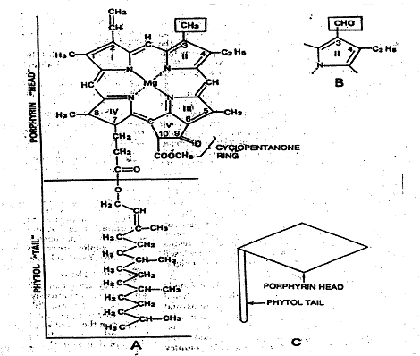

**PAPER CHROMATOGRAPHY**

The basis of all forms of chromatography is the partition and distribution coefficient (Kd) which describes the way in which a compound distributes itself between two immiscible phases. For a compound distributing itself between equal volumes of two immiscible solvents A and B, the value for this coefficient is a constant at a given temperature and is given by the expression: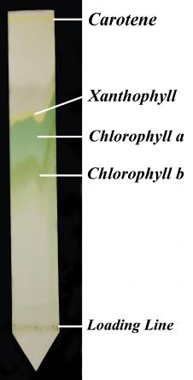

Concentration in solvent A = Kd

Concentration in solvent B

The distribution of a compound can, however, be described not only in terms of its distribution between two solvents, but also by its distribution between any two phases, such as solid/liquid or gas/liquid phases. Thus a distribution coefficient of a substance between silicic acid and benzene might be 0.5, which means that the concentration of the substance in benzene is twice than that in the silicic acid.

The cellulose fibres of chromatography paper act as the supporting matrix for the stationary phase. The stationary phase may be water, a non polar material such as liquid paraffin or impregnated particles of solid adsorbent. Paper chromatography is the method in which the analysis of an unknown substance is mainly done by the flow of solvents on specially designed filter paper. Paper chromatography separates compounds on paper as solvent carries the mixture up the paper by capillary action. Compounds which are highly soluble in the solvent move along with the advancing solvent front, while less soluble compounds travel slowly through the paper, well behind the solvent front. As a result the different compounds are separated on the basis of their solubility in the chosen solvent

Rf is defined as the ratio of the distance travelled by compound at its point of maximum concentration to the distance travelled by solvent. Both the distances are measured from the point of application of the sample. Rf value has no unit.

Rf = Distance travelled by substance

Distance travelled by solvent

**REQUIREMENTS**

1. Coin
2. Petroleum Ether
3. Acetone
4. Distilled Water
5. Solvent preparation:Mix Petroleum Ether, Acetone and water in the ratio of 3: 1: 1.

**PROCEDURE**

**Sample Loading:**

1. Take the rectangular sheet of Whatman No. 1 filter paper.
2. Mark a pencil line to mark the locus of putting the leaf extract. Make sure to keep this line almost 5 cm. from any of the longer side corner.
3. Place the leaf on the pencil line, and start rolling the coin with lesser force, to transfer the leaf constituents on the marked line.

**Sample chromatographic run:**

1. Take 25 ml of solvent in a jar and cover with lid.
2. Put down the paper into the solvent, making sure that marked line portion does not come in direct contact with the solvent.
3. Run chromatogram for 1 hour.
4. Take paper out and mark solvent front with a pencil.

The different pigments will appear like lines on the paper at different distance from the starting point, measure Rf value and record.

**OBSERVATION**

| **Parameter** | **Distance travelled(cm)** |
| --- | --- |
| Solvent |  |
| Chl a |  |
| Chl b |  |
| Xanthophylls |  |
| Carotene |  |

Rf. of various pigments is calculated by using formula:

Rf = Distance traveled by pigment

Distance traveled by solvent

Rf of Chl a =

Rf of chl b=

Rf of carotene=

**RESULTS**

Retention Factor of

Chl a =

Chl b=

Carotene=

**MARKS OBTAINED**

**SIGNATURE OF INSTRUCTOR**

**REVIEW QUESTIONS**

1. What will happen if plants are exposed to green light?
2. Name the central element present in chlorophyll.
3. What is the partition coefficient?
4. Mention one structural difference between Chl a and Chl b.
5. What are Carotenoids?

**EXPERIMENT No. 8**

**OBJECTIVE**   
To study the phenomenon of plasmolysis in onion peel

**THEORY**

**Plasmolysis** is the process in plant cells where the plasma membrane pulls away from the cell wall due to the loss of water through osmosis. The reverse process, cytolysis, can occur if the cell is in a hypotonic solution resulting in a higher external osmotic pressure and a net flow of water into the cell. Through observation of plasmolysis it is possible to determine the tonicity of the cell's environment as well as the rate solute molecules cross the cellular membrane.

If a plant cell is placed in a hypertonic solution, the plant cell loses water and hence [turgor](http://en.wikipedia.org/wiki/Turgor) pressure, making the plant cell flaccid. Plants with cells in this condition wilt. Further water loss causes plasmolysis: pressure decreases to the point where the protoplasm of the cell peels away from the cell wall, leaving gaps between the cell wall and the membrane. Eventually [cytorrhysis –](http://en.wikipedia.org/wiki/Cytorrhysis) the complete collapse of the cell wall – can occur. There are some mechanisms in plants to prevent excess water loss in the same way as excess water gain, but plasmolysis can be reversed if the cell is placed in a weaker solution (hypotonic solution). Stomata help keep water in the plant so it does not dry out. Wax also keeps water in the plant. The equivalent process in animal cells is called [crenation.](http://en.wikipedia.org/wiki/Crenation)

Plasmolysis only occurs in extreme conditions and rarely happens in nature.

**REQUIREMENTS**

1. Onion, cut into slices approximately 1 cm wide, 1or 2
2. Microscope
3. Microscope slides,1per specimen
4. Cover slips, 1 per specimen
5. Distilled water
6. Salt solution (sodium chloride) 5% w/v
7. Rubber bulb
8. Pipettes
9. Forceps
10. Filter paper

**PRECAUTIONS**

1. Onion may irritate some students’ eyes to the point of discomfort. It may be dipped in hot water to avoid it.

2. Take care with microscope slides and (especially) cover slips which are fragile and break easily. Ensure students know how to deal with broken glass.

**PROCEDURE**

**1.** Cut a 1 cm square of onion. Then peel off a single layer of the red cells from an inner fleshy leaf of the onion.

**2.** Place the strip on a slide. Cover it with a drop of distilled water. Add a cover slip.

**3.** Look at the cells through a microscope, starting with the low power lens.

**4.** Take another strip of cells from your plant material. This time mount the cells with a couple of drops of 5% sodium chloride solution.

**5.** Examine through the microscope and compare the cells to those mounted with distilled water.

**6.** After a few minutes draw out the sodium chloride solution with a piece of filter paper placed at the edge of the coverslip. Replace it with distilled water added at the other side of the coverslip.

**7.** See what happens to the cells.

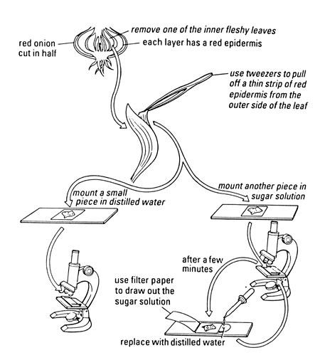

**OBSERVATION**

**A. Cells mounted in presence of water**

**General features**

**Diagram**

**B. Cells mounted in presence of sodium chloride**

**General features**

**Diagram**

**RESULTS:**

**MARKS OBTAINED**

**SIGNATURE OF INSTRUCTOR**

**REVIEW QUESTIONS**

**1.** Explain what happened to the cells in sodium chloride solution using biological terms.

Try to include these words.

1. Cytoplasm
2. Diffusion
3. Water
4. Solvent
5. Dissolved salts
6. Solute
7. Cell membrane
8. Vacuole
9. Cell wall
10. Osmosis
11. Plasmolysis
12. Turgid
13. Flaccid
14. Turgor

**2.** What prevents the plant cells from bursting when they take in lots of water?

**3.** You’ve seen what happens to cells in epidermal tissue when they lose water. How does a whole plant look when it is short of water? How does it change when you give it water? Try to explain these observations using the ideas above.

**4.** Animal cells do not have the same structure as plant cells. What do you think could happen to an animal cell in water?

**5.** What would you do to investigate this process further?

**EXPERIMENT No. 9**

**OBJECTIVE:**

1. Determination of total cholesterol from egg-yolk
2. Determination of Body-Mass index
3. **Total Cholesterol**

**Introduction:**

Cholesterol, as a constituent of all biological membranes, is an essential lipid. Apart from that, it is the biosynthesis precursor of numerous steroid hormones, of vitamin D and bile acids. Due to their low solubility in water, cholesterols and cholesterol esters will only be found in the plasma as forms attached to various lipoproteins. Cholesterol is taken up with the food, but also synthesized endogenously. It is excreted via the skin, the gall and the intestines; reabsorption via the biliary cycle is possible as well. Cholesterol determination serves the purpose of early diagnosis of the risk for arteriosclerosis, of monitoring therapies with lipidlowering drugs as well as the diagnosis of hyperlipoproteinic and hypolipoproteinic diseases. When high triglyceride and/or cholesterol values are measured in the serum of a patient after 12 hours of alimentary abstinence, hyperlipoproteinaemia is proven. Hyperlipoproteinaemias are metabolic diseases based on increased synthesis or delayed decomposition of lipoproteins transporting cholesterol and triglycerides in the blood plasma. Increased plasmalipoprotein concentrations cause arteriosclerosis. In case of hereditary causes, these diseases are called primary hyperlipidaemias. When the increase of blood lipids occurs within the framework of a disease (e.g. diabetes mellitus, kidney disease, alcoholism), it is called secondary hyperlipidaemia. Secondary hyperlipidaemias occur more frequently. Hyperhomocysteinaemia is rated as an independent risk factor for atherosclerotic angiopathies. Increased homocystein levels lead to damages at the endothelium of blood vessels. It occurs mostly in case of vitamin B12, -B2 and B6 deficiencies as well as folic acid deficiency.

**Principle:**

Following enzymatic hydrolysis of the cholesterol esters, the entire cholesterol complex is oxidized by oxygen from the air. In this process, hydrogen peroxide is generated, which, in combination with phenol and 4-aminophenazon under the effect of peroxidase, produces a red dye (Quinonimine Complex), the extinction of which is determined at 505 nm. The intensity of its colour is directly proportional to the cholesterol concentration and is calculated with the aid of a standard.

**Reaction:**

Cholesterol Ester + H2O Cholesterol + Fatty acids

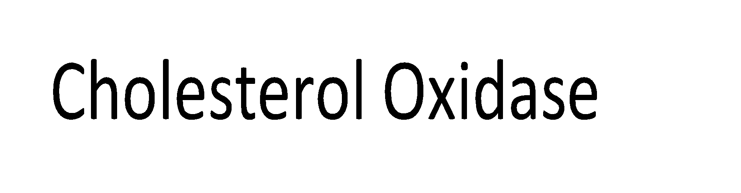

Cholesterol + O2 Cholest 4-en-3-One + H2O2



2H2O2 + Phenol + 4-Aminoantipyrine Quinonimine + 4 H2O

**Procedure:**

Add the reagent according to following table:

| Sr. No. | Cholesterol Reagent | Cholesterol Standard | Test Sample | Absorbance at 505 nm |
| --- | --- | --- | --- | --- |
| Blank | 1 | -------- | -------- | 0 |
| Standard | 1 | 10 ul | -------- |  |
| Test | 1 | ------- | 10 ul |  |

Mix all the tubes and keep it for incubation for 5 minutes at room temperature. The pink or red color will develop according to concentration of cholesterol in test samples.

Note down the absorbance of standard and test samples at 505 nm.

**Note:** The conc. of cholesterol standard is **200 mg/100 ml.**

Normal range of serum cholesterol is 130-250 mg/100 ml.

Calculate the Total cholesterol by using formulae given below.

**Total cholesterol (mg/100 ml) = (Absorbance of Test /Absorbance of Standard) X 200**

**Note:** Due to lack of Blood serum, we are using egg yolk as a cholesterol test sample. You will be provided with egg yolk diluted in distilled water.

**RESULT:**

The concentration of cholesterol in test sample was found to be __________ mg/100 ml

1. **Body-Mass Index**

The body mass index (BMI) is the metric currently in use for defining anthropometric height/weight characteristics in adults and for classifying (categorizing) them into groups. The common interpretation is that it represents an index of an individual’s fatness. It also is widely used as a risk factor for the development of or the prevalence of several health issues. In addition, it is widely used in determining public health policies.The BMI has been useful in population-based studies by virtue of its wide acceptance in defining specific categories of body mass as a health issue. However, it is increasingly clear that BMI is a rather poor indicator of percent of body fat. Importantly, the BMI also does not capture information on the mass of fat in different body sites. The latter is related not only to untoward health issues but to social issues as well. Body Mass Index (BMI) is a person’s weight in kilograms (or pounds) divided by the square of height in meters (or feet). A high BMI can indicate high body fatness. It is expressed in [units](https://en.wikipedia.org/wiki/Units_of_measurement) of kg/m2.

The BMI is a convenient [rule of thumb](https://en.wikipedia.org/wiki/Rule_of_thumb) used to broadly categorize a person based on tissue mass ([muscle](https://en.wikipedia.org/wiki/Muscle), [fat](https://en.wikipedia.org/wiki/Fat), and [bone](https://en.wikipedia.org/wiki/Bone)) and height. Major adult BMI classifications are [*underweight*](https://en.wikipedia.org/wiki/Underweight) (under 18.5 kg/m2), [*normal weight*](https://en.wikipedia.org/wiki/Normal_weight) (18.5 to 24.9), [*overweight*](https://en.wikipedia.org/wiki/Overweight) (25 to 29.9), and [*obese*](https://en.wikipedia.org/wiki/Obese) (30 or more).

**BMI Categories:**

Underweight = <18.5

Normal weight = 18.5–24.9

Overweight = 25–29.9

Obesity = BMI of 30 or greater

**Calculation:**

**BMI = Mass (kg)**



**Height2 (m)**

**Result:**

The body-mass index of the subject is found to be _________ kg/m2 and hence the BMI category

assigned is _____________.

**Marks obtained:**

**Signature of the Instructor:**

**EXPERIMENT No. 10**

**OBJECTIVE**   
Measurement of Blood Pressure by using a digital blood pressure measuring instrument.

|  |  |  |
| --- | --- | --- |
|  |  |  |

**THEORY**   
Blood pressure (BP) is the pressure exerted by circulating blood upon the walls of blood vessels. For each heartbeat, BP varies between systolic and diastolic pressures. Systolic pressure is peak pressure in the arteries, which occurs near the end of the cardiac cycle when the ventricles are contracting. Diastolic pressure is minimum pressure in the arteries, which occurs near the beginning of the cardiac cycle when the ventricles are filled with blood. The mean BP, due to pumping of blood by the heart and resistance to flow in blood vessels, decreases as the circulating blood moves away from the heart through arteries. Along with body temperature, respiratory rate, and pulse rate, BP is one of the four main vital signs routinely monitored by medical professionals and healthcare providers.

Pressure drops gradually as blood flows from the major arteries, through the arterioles, the capillaries until blood is pushed up back into the heart via the venules, the veins through the vena cava with the help of the muscles. At any given pressure drop, the flow rate is determined by the resistance to the blood flow. In the arteries, with the absence of diseases, there is very little or no resistance to blood. The vessel diameter is the most principal determinant to control resistance. Compared to other smaller vessels in the body, the artery has a much bigger diameter (4mm), therefore the resistance is low.

The physiological parameters affecting blood pressure are given below. These are in turn influenced by physiological factors, such as diet, exercise, disease, drugs or alcohol, stress, obesity, etc.

1. Heart rate: The rate at which blood is pumped by the heart. The volume of blood flow from the heart is called the cardiac output which is the heart rate (the rate of contraction) multiplied by the stroke volume (the amount of blood pumped out from the heart with each contraction).
2. Volume of fluid or blood volume, the amount of blood that is present in the body. The more blood present in the body, the higher the rate of blood returns to the heart and the resulting cardiac output. There is some relationship between dietary salt intake and increased blood volume, potentially resulting in higher arterial pressure, though this varies with the individual.
3. Resistance of the blood vessels. The higher the resistance, the higher the arterial pressure upstream from the resistance to blood flow. Resistance is related to vessel radius (the larger the radius, the lower the resistance), vessel length (the longer the vessel, the higher the resistance), blood viscosity, as well as the smoothness of the blood vessel walls. Smoothness is reduced by the buildup of fatty deposits on the arterial walls. Substances called [vasoconstrictors](http://en.wikipedia.org/wiki/Vasoconstrictor) can reduce the size of blood vessels; thereby increasing BP. [Vasodilators](http://en.wikipedia.org/wiki/Vasodilator) (such as nitroglycerin) increase the size of blood vessels, thereby decreasing arterial pressure.
4. Viscosity of the fluid. If the blood gets thicker, the result is an increase in arterial pressure. Certain [medical conditions](http://en.wikipedia.org/wiki/Medical_conditions) can change the viscosity of the blood. For instance, anemia (low red blood cell concentration) reduces viscosity, whereas increased red blood cell concentration increases viscosity.

MEASUREMENT

Blood pressures are usually expressed as a ratio of systolic to diastolic pressure. The normal blood pressure of an adult male is about 120 mmHg systolic and 80 mmHg diastolic, abbreviated to 120/80. The difference between systolic and diastolic pressure is called pulse pressure. Pulse pressure may be used clinically to indicate several physiological and pathological parameters, and usually averages 40 mmHg in a healthy individual. The ratio of systolic pressure to diastolic pressure to pulse pressure may also be utilized clinically as a diagnostic tool, and is usually 3:2:1.

Arterial pressure is most commonly measured via a sphygmomanometer, which historically used the height of a column of mercury to reflect the circulating pressure. BP values are generally reported in millimeters of mercury (mmHg), though aneroid and electronic devices do not use mercury. Average blood pressure of adults is 110/65 – 140/90 mmHg. A sphygmomanometer consists of an inflatable rubber cuff attached by a rubber tube to a compressible hand pump or bulb. Another tube attaches to a cuff and to a mercury column marked off in millimeters or an aneroid gauge that measures the pressure in mm Hg. The sounds of blood flow are heard within a stethoscope. Blood flow in an artery is impeded by increasing pressure within a sphygmomanometer. When the cuff of the sphygmomanometer applies sufficient pressure to completely occlude blood flow, no sounds can be heard distal to the cuff because no blood can flow through the artery. When cuff pressure drops below the lowest (diastolic) pressure in the vessel, the sound becomes muffled and usually disappears. The sounds heard through the stethoscope via this procedure are termed korotkoff sounds. The present exercise employs the oscillometric for measurement of blood pressure. This method involves the observation of oscillations in the sphygmomanometer cuff pressure which are caused by the oscillations of blood flow, i.e., the pulse. It uses a sphygmomanometer cuff, like the auscultatory method, but with an electronic pressure sensor (transducer) to observe cuff pressure oscillations, electronics to automatically interpret them, and automatic inflation and deflation of the cuff. The pressure sensor should be calibrated periodically to maintain accuracy. Oscillometric measurement requires less skill than the auscultatory technique and may be suitable for use by untrained staff and for automated patient home monitoring.

In this method the cuff is inflated to a pressure initially in excess of the systolic arterial pressure and then reduced to below diastolic pressure over a period of about 30 seconds. If blood flow is nil (cuff pressure exceeding systolic pressure) or unimpeded (cuff pressure below diastolic pressure) the cuff pressure will be essentially constant.

To get an accurate reading one should not drink coffee, smoke cigarettes, or engage in strenuous exercise at least 30 minutes before taking the reading. A full bladder may have a small effect on BP readings; if the urge to urinate exists, one should do so before the reading. For 5 minutes before the reading, one should sit upright in a chair with one's feet flat on the floor and with limbs uncrossed. The BP cuff should always be against bare skin, as readings taken over a shirt sleeve are less accurate. During the reading, the arm that is used should be relaxed and kept at heart level, for example by resting it on a table.

An example of normal measured values for a resting, healthy adult human is 120 mmHg systolic and 80 mmHg diastolic (written as 120/80 mmHg). Systolic and diastolic arterial BPs are not static but undergo natural variations from one heartbeat to another and throughout the day (in a circadian rhythm). They also change in response to stress, nutritional factors, drugs, disease, exercise, and momentarily from standing up. Sometimes the variations are large. Hypertension refers to arterial pressure being abnormally high, as opposed to hypotension, when it is abnormally low.

REQUIREMENTS

1. Blood pressure Instrument
2. Volunteer

PROCEDURE

1. The volunteer should be comfortably seated with arm bared, slightly flexed, abducted, and perfectly relaxed. You may, for convenience, rest the forearm on a table in the supinated position.
2. Wrap the deflated cuff of the Instrument around the arm with the lower edge about 1 inch above the antecubital space. Close the valve on the neck of the rubber bulb.
3. Clean the earpieces of the stethoscope with alcohol before using it. Using the diaphragm of the stethoscope, find the pulse in the bronchial artery just above the bend of the elbow, on the inner margin of the biceps bronchi muscle.
4. Inflate the cuff by squeezing the bulb until the air pressure within it just exceeds 170 mm Hg. At this point the wall of the bronchial artery is compressed tightly, and no blood should be able to flow through.
5. Gradually release the pressure from the cuff using the knob.
6. Record all results in the observation table.
7. Now, assuming that the volunteer does not have any apparent cardiac or other health problems, and is capable of such an activity, ask him to do some exercise, such as jogging in the same place for 40 to 50 times and measure the blood pressure again immediately after the completion of the exercise. Also record these results in the observation table provided at the end of the exercise.

**OBSERVATIONS**

**RESULTS**

**MARKS OBTAINED**

**SIGNATURE OF INSTRUCTOR**

**REVIEW QUESTIONS:**

1. Explain in what way the following factors affect the blood pressure.
2. Diet
3. Exercise
4. Alcohol,
5. Stress
6. Obesity
7. Comment on dietary restrictions to the patients suffering from hypertension?
8. Name the Auscultatory method used for measuring blood pressure? Is there any additional Instrument required?
9. Do you think patients with Hypotension could donate blood? Justify your answer.

**EXPERIMENT No. 11**

**OBJECTIVE**To observe the given slides, identify the parts, draw the diagram and comment on the slides .

**SLIDE 1.**

**Characteristics:**

**Diagram:**

**SLIDE 2.**

**Characteristics:**

**Diagram:**

**SLIDE 3.**

**Characteristics:**

**Diagram:**

**SLIDE 4.**

**Characteristics:**

**Diagram:**

**SLIDE5.**

**Characteristics:**

**Diagram:**

**MARKS OBTAINED:**

**SIGNATURE OF INSTRUCTOR:**

***Please check the relevant presentation uploaded for Expt. 11*EXPERIMENT No. 12**

**OBJECTIVE**: Computational annotation of nucleic acids and proteins

**Computational annotation: *in silico* characterization**

Computational biology involves the science of development and application of data-analytical and theoretical methods, mathematical modeling and computational simulation techniques to the study of biology. The field is broadly defined and includes foundations in computer science, applied mathematics, animation, statistics, biochemistry, chemistry, biophysics, molecular biology, genetics, genomics, ecology, evolution, anatomy, neuroscience, and visualization. Computational biology is different from biological computation, which is a subfield of computer science and computer engineering using bioengineering and biology to build computers, but is similar to bioinformatics, which is an interdisciplinary science using computers to store and process biological data.

Over years of research, several computational biology tools and databases have been created for developing rapid, knowledge-based intuitive prediction methods.

**EMBOSS (The European Molecular Biology Open Software Suite)**:

It is a free Open Source software analysis package specially developed for the needs of the

molecular biology (e.g. EMBnet) user community. The software automatically copes with data in a variety of formats and even allows transparent retrieval of sequence data from the web. Also, as extensive libraries are provided with the package, it is a platform to allow other scientists to develop and release software in true open source spirit. EMBOSS also integrates a range of currently available packages and tools for sequence analysis into a seamless whole. EMBOSS breaks the historical trend towards commercial software packages.

For this experiment we are using **EMBOSS explorer** (<http://bioinfo.nhri.org.tw/gui/>).

**Sequence Statistics:** **Pepstats** (Calculate properties of protein sequences such as molecular weight), **Pepinfo** (Create a variety of plots that display different amino acid properties, such as hydropathy or charged residues, and their position in the sequence)

**Pairwise Sequence Alignment:** **Needle** (Create an optimal global alignment two sequences using the Needleman-Wunsch algorithm), **Water** (Use the Smith-Waterman algorithm to calculate the local alignment of two sequences)

**Sequence Translation:**

**Transeq** (Translate nucleic acid sequences to the corresponding peptide sequences).

**Pepstats**

**Pepstats** outputs a report of simple protein sequence information including:

* Molecular weight
* Number of residues
* Average residue weight
* Charge
* Isoelectric point
* For each type of amino acid: number, molar percent, DayhoffStat
* For each physico-chemical class of amino acid: number, molar percent
* Probability of protein expression in E. coli inclusion bodies
* Molar extinction coefficient (A280)
* Extinction coefficient at 1 mg/ml (A280)

**FASTA format**

FASTA format is a text-based format for representing either nucleotide sequences or peptide sequences, in which base pairs or amino acids are represented using single-letter codes. A sequence in FASTA format begins with a single-line description, followed by lines of sequence data. The description line is distinguished from the sequence data by a greater-than (">") symbol in the first column.

**MARKS OBTAINED:**

**SIGNATURE OF INSTRUCTOR:**

**EXPERIMENT NO 13**

**OBJECTIVE**: To determine the tissue location of the endogenous enzymes polyphenol

oxidase in a variety of vegetables, fruits, and mushrooms.

**THEORY**:

Tissue printing was reviewed by Varner and Ye and was defined by the authors as the art and science of visualizing cellular material and information that are transferred to a receptive surface when the cut surfaces of sections (1/4 inches thick) of tissues or organs are pressed against such a surface. Using this simple technique, the cell-specific location of various macromolecules, such as proteins, enzymes, nucleic acids, or soluble metabolites, can be determined by exposing the ‘print to a chemical reagent that allows the molecule of interest to be visualized (e.g. by use of histochemical or immunochemical methods).

Different species, or tissues from a single species, can be quickly screened for the presence of a particular macromolecule by tissue printing. The technique can also be used to follow changes in the tissue distribution of a particular protein or enzyme throughout the course of an organism’s development. In tissue printing, cell contents from the surface of a cut section of the tissue are transferred to an adsorptive surface, commonly a nitrocellulose membrane. Because of the considerable expense of nitrocellulose, this procedure utilizes artists’ hot-press watercolor paper as a novel and more economical alternative. Blotting paper can also be used for the same. Tissue prints are then exposed to an enzyme substrate from which an insoluble, colored product is produced. The appearance of color in specific areas of the print is an indication of the presence of the enzyme in those tissue locations.

PPO, often called tyrosinase, is an enzyme that occurs in many species of plants and fungi. It is homologous to mammalian tyrosinase, an enzyme involved in melanin formation.

PPO is a metalloenzyme containing two active-site copper ions that are essential for enzymatic activity. It catalyzes a redox reaction in which various phenolic compounds are oxidized, ultimately leading to the production of dark-colored pigment molecules which cause the familiar browning of vegetables, fruits, and mushrooms as they age or when they are bruised. Because of its role in the production of these melanin-like polymers, PPO is believed to be an important part of plant/fungal defense mechanisms against insects and pathogens. Melanin-like product formation by PPO is of great concern to the agricultural industry because postharvest browning of product results in considerable economic loss because of the alteration of color, flavor, and nutritional value.

**PROCEDURE**

1) Pour some of the catechol/MBTH solution (PPO substrate) into a plastic weighing boat.

2) Cut small pieces of the watercolor paper. You will need two pieces of paper for each vegetable that will be studied, and each piece of paper should be large enough so that a cross-section of the vegetable can be printed on it.

3)Make a total of 4 prints-one with substrate but no tissue,2 with tissues provided and the one with a boiled control

4) Use a new razor blade to cut a ¼ inches thick cross-section of celery from the middle region of a celery stalk. Try to make a clean, vertical cut so that the cut surface is as flat as possible.

Do not touch the cut surfaces of the celery slice. Rather, touch only the outer surface where the skin is intact. Place a piece of the watercolor paper on a very smooth, flat surface. Carefully, without shifting its position, place one cut surface of the celery slice onto the watercolor paper. Place a microscope slide on top of the celery slice and press down firmly for about 10 seconds by applying pressure with your thumb directly on top of the celery, attempting to distribute pressure evenly over the celery slice. This will transfer the cellular contents from the cut celery surface onto the paper, leaving a ‘celery print. Remove the microscope slide and the celery slice, being careful not to smear the print by sliding the celery across the surface of the paper.

5) Using forceps, dip the print labeled ‘PPO(polyphenol oxidase), celery into the catechol/MBTH(3-methyl-2-benzo-thiazolinone hydrazone). solution. Be sure that the entire surface of the paper is covered by the solution; then quickly remove it and place it on some paper towels. While wearing gloves, use more paper towels to lightly blot the top surface of the print to prevent pooling of excess liquid on the surface of the paper.

6)Monitor the color development on both prints for a few minutes, taking note of how quickly color appears in various regions of the prints. Then set the celery prints aside and continue working on the tissue prints for other vegetables. Color should develop within 5 minutes, but small changes may still occur for another 10–15 minutes. Therefore, examine the prints again after some time.

**Requirements**

1. Artists’ watercolor paper with a very smooth surface is needed.

2. An assortment of fresh vegetables, mushrooms, or fruits is also needed. Recommended celery, parsnips, button mushrooms, and radishes.

3. PPO substrate solution: 1 mM catechol and 1 mM MBTH in 50 mM phosphate buffer, pH 6.5, containing 2% (v/v) (Dimethyl formamide) The solution will be clear initially, but will almost immediately develop a light pink tint which will become darker with time. The light pink color does not adversely affect the quality of the tissue prints.

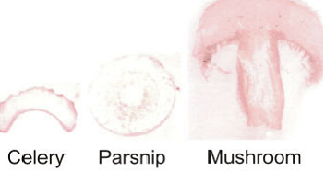

Tissue print of PPO enzyme in different types of samples. Pink color indicates the presence of the enzyme.

**RESULTS**

Record intensity compared to celery treated with no substrate

**OBSERVATIONS**

**MARKS OBTAINED**

**SIGNATURE OF INSTRUCTOR**

**Review questions**

1.What is the necessity of PPO enzyme monitoring in plant cells? Is this of economic value?

2.What are the two kinds of enzymes found inside the cells of plants?

3.Why is it necessary to put a control of plant tissue without substrate?

4.Is there a way by which browning of vegetables and fruits could be arrested?

**BIBLIOGRAPHY**

1. Cappuccino, J.G. and Sherman., N.1983. Microbiology: A laboratory Manual, Addison – Wesley Publishing Company, California.
2. Enger, E.D. and Ross, F.C. 2000. Concepts in Biology, Mcgraw Hill Publishers, New York.
3. Lehninger, A.L. 1992. Biochemistry, Worth publishers.
4. Mckee, T. and Mckee, J.R. 1999. Biochemistry – an introduction, WCB/McGraw Hill publishers, USA.
5. Moore, T.C. 1974. Research Experiments in Plant Physiology – A laboratory Manual. Springer – Verlag, New York.
6. Plummer, D.T.. 1982. An introduction to Practical Biochemistry (2nd Edition), Tata McGraw Hill Publishing Company Ltd., New Delhi.
7. Raven, P.H. and Johnson, G.B. 1999. Biology (5th Edition), WCB/McGraw Hill Publishers, USA.
8. Sadava, D.E. 1993. Cell Biology – Organelle Structure & Function, Johnes and Barlet Publishers.
9. Salisbury, F.B. and Ross, C. 1969. Plant Physiology, Wadsworth Publishing Company, California.
10. White, A, Handler, P. and Smith, E.L. 1973. Priniciples of Biochemistry (5th Edition) McGraw – Hill Kogakusha Ltd. London.
11. Witham, F.H., Blaydes, D.F. and Devlin, R.M. 1971. Experiments in Plant Physiology. Van Nostrand Reinhold Company Ltd., Canada
12. [www.practicalbiology.org](http://www.practicalbiology.org)
13. J .E. Varner, Z. Ye (1994) Tissue printing, FASEB J. 8, 378–384.
14. Biochemistry and Molecular Biology Education Vol. 37, No. 2, pp. 92–98, 2009

**NOTES:**